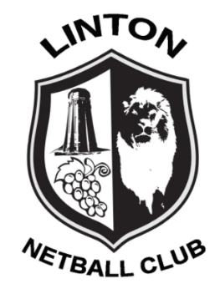
Linton Netball Club: Code of Conduct for Coaches, Umpires, Table Officials, Team Managers, Teachers, Tutors, Assessors, Testers, Trainers, Verifiers and Mentors and all Volunteers participating in Netball

The Code of Conduct states the values and standards expected at all times. In addition to these, when in my capacity as a coach, umpire, table official, team manager, teacher, tutor, assessor, tester, trainer, verifier, mentor or volunteer.

I will also:
- Be a positive role model for netball by acting in a way that projects a positive image of my role within netball and being fair, considerate and honest with participants and officials

- Display high standards in my language, manner, punctuality, preparation and presentation to ensure that all time spent with me by participants or colleagues is a positive experience

- Exercise reasonable care and skill when carrying out my duties, including but not limited to keeping up to date with the latest practices and developments by taking up further education and other personal and professional development opportunities

- Be consistent, independent and demonstrate complete impartiality through exercising reasonable care and skill to enforce the rules of the game by applying them fairly and to effect control of the game

- As a coach, seek to inspire and motivate in accordance with an individual’s abilities to enable them to play to the best of their ability and realise their potential

- As a coach, provide athletes with planned and structured training programmes appropriate to their abilities and goals by ensuring that equal attention and opportunities are available to all, including those requiring a modified plan due to sickness or injury

- As a tutor, assessor, tester, trainer, verifier or mentor, provide candidates with the appropriate information, planned and structured programmes appropriate to their needs and goals, ensuring that equal attention is applied, and to provide appropriate feedback following observation of a session

- Be mentally and physically fit to carry out my role within netball

- Ensure that the training and/or competition environment is safe and appropriate for the age, physical and emotional maturity, experience and ability of the athletes

- Ensure that I follow instructions and comply with all health and safety regulations that apply to the role I am undertaking.

I will endeavour to abide by this code of conduct and promote it to others. I understand that if I fail to follow the code, the England Netball, the Regional Association or the County Association may take action against me under the Disciplinary Regulations which may result in Sanctions including fines and suspension.

